MTB Trails Assessment - from a single access point
Access Point: Cedar Flats
Address or GPS of parking/staging area: 48.4198, -114.1699
Phone Coverage of area considered (Please draw map with locations of service if service is limited. Also include which providers have service in these areas): Phone coverage is limited. Under power lines on South side of 6302 and on the north side of trails in drainages it is worse. Verizon has 1-2 bars in most places.
Roadways to/from site:
Roadway Number/Name | Surface Type | Anticipated Conditions | Anticipated Traffic | Hazards
North Fork Road | Paved | Construction at Nucleus and North Fork Road | Minimal | Deer
Cedar Lake Road | Gravel | Washboard, Potholes | Minimal | Fallen Trees, washouts from rain

Drive time to site: n/a
Drive distance to site: n/a
Insert map with alternate routes outlined.

Parking:
Space for large vehicles? Up to 30’ total length
Space for large vehicles with trailer? Up to 30’ total length
How many parking spots (estimated): 10
Room to turn around with trailer? Yes, if empty.
Mandatory backing with trailer? If parking area is not empty, yes. At both forest service gates there is enough room to back in for a turn around.

Facilities:
Restrooms: None
Surface types: N/A

Medical:
If no phone service – radio band and frequency for emergency services: 155.760 (FC Dispatch)
Agency | Miles from TH | Best Drive Time | Address | Phone
Three Rivers EMS | 4.5 | 9 min | 627 6th Ave W  Columbia Falls, MT 59912 | 911
North Valley Hosp | 12 | 19 min | 1600 Hospital Way  Whitefish, MT 59937 | 911  863-3500
Logan Health | 21 | 33 min | 310 Sunnyview Ln  Kalispell, MT 59901 | 911  752-5111

Medical Access Points (attach a map):
Access Point | Road/Location | GPS | Response Time
EMS 1 | Cedar Lakes Road (Trailhead) | 48.4198, -114.1699 | 11 minutes
EMS 2 | North Fork Loop off of North North Fork Road under power lines | 48.3999, -114.1648 | 7 minutes
LZ | Forest Service Road 10815 and Cedar Flats Road. | 48.4130, -114.1821 | varies
LZ | North Fork Loop, North Entrance | 48.3999, -114.1647 | varies

General Use:
Anticipated Public Activities at Site: Hiking, Horseback Riding, Biking, Dirt Biking, 4-Wheeling, Shooting (target), Hunting (Fall), Dogs on and off leash
Anticipated Public Loads at Site – Weekdays: Minimal
Anticipated Public Loads at Site – Weekends/Holidays: Minimal
Demographic of Public: Varies

Permits:
Permits or Permission needed to Operate: n/a
When applications are due: n/a
When permits are drawn: n/a
Cost of permits: n/a
Permit Contact Agency: Flathead National Forest
Permit Contact Person: Chip Weber, Glacier View Ranger District
Permit Contact Phone: 406-387-3800

Trails - attached a map with the following outlined
Trail Name - For each trail on map
🟢, 🟦, ⯁, ⯁⯁Trail Rating for adaptive bikes for each trail (Beginner, Intermediate, Advanced, Expert)
EMS 1, EMS 2, EMS 3... - Access points for Emergency Medical Services
H1, H2, H3, H4, H5... - Known hazards, with a description of each on the back of the map
1, 2, 3, 4… - Trail Junctions (areas where folks could take wrong turns
A, B, C, D… - Sections of the trails based on EMS access points. A would be the response area coming in from EMS 1, B would be the response area coming in from EMS 2, etc.
@ - Half-way point in time on the trail if a loop. This is your commit point if you are past it to finish the ride, or turn back if you are not to the commit point and you have met your time deadline.

SIGNIFICANT HAZARDS IDENTIFIED  (Equipment, Environment, People) | PERSONS AT RISK | RISK RATING |  |  | CONTROL MEASURES | DATE ACTIONED  and  SIGNATURE
 | PERSONS AT RISK | HAZARD | RISK | RISK RATING | CONTROL MEASURES | DATE ACTIONED  and  SIGNATURE
Wind - Area has been logged and with unstable ground and increased forces on standing trees, potential for trees to fall. | Staff  Volunteers  Participants | 1 | 1 | 1 | Check weather prior to ride. Winds over 40mph and we discuss as a team to cancel or postpone ride. | 5/30/21 TH
Rain - With flat terrain, low lying area, and tall trees, hard to see weather comes in. Rain increases likelihood of trees falling over, difficulty steering due to muddy trails, and hypothermia. | Staff  Volunteers  Participants | 1 | 2 | 2 | Check weather prior to ride. Significant storm cells within ride time will be discussed as a team to cancel or postpone ride. Other precip will be discussed in the pre-ride brief. | 5/30/21 TH
Bears, Cats, Moose, Elk, and other animals | Staff  Volunteers  Participants | 5 | 2 | 10 | Instructors and Volunteers carry Bear Spray. Continue to use voices. | 5/30/21 TH
Gunshots - Locals use this area for hunting and general target shooting. | Staff  Volunteers  Participants | 5 | 2 | 10 | Wear bright colors in the fall. Listen for gunshots before ride. If shots are fired, re-route if necessary to move away from source. | 5/30/21 TH
Tip Over Hazards - Sections of the trail that are off-pitch and present tip-over hazards. | Staff  Volunteers  Participants | 3 | 3 | 9 | Identification and Spotting. | 5/30/21 TH
Sticks Everywhere - With recent logging in 2021, sticks are everywhere and can be thrown by or caught in tires. | Staff  Volunteers  Participants | 3 | 2 | 6 | Eye protection and Instructors move sticks where necessary. Education for participants on how to ride over sticks. | 5/30/21 TH
Water - Standing water in a couple of places on trail after rain and in spring. If participants get off track in water and fall over, drowning potential. | Staff  Volunteers  Participants | 5 | 2 | 10 | Identification and Spotting for all participants that cross into water hazards. | 5/30/21 TH

Assessed by: Trevor Hildebrand
Assessed on: 5/30/21
Signature: 

Reviewed by:
Reviewed on:
Signature:

Risk Rating
Hazard  (Severity) | Value | Risk  (Likelihood)
Negligible | 1 | Unlikely
Slight | 2 | Possible
Moderate | 3 | Quite Possible
Severe | 4 | Likely
Very Severe | 5 | Very Likely

Hazard Value x Risk Value = Risk Level

Ranking of Risk
(Risk Level)
1 – 4 | Low Risk
5 – 15 | Medium Risk
16 - 25 | High Risk

Low Risk – risk can be acceptable
Medium Risk – acceptable with adequate control measures in place.
High Risk – action must be prioritized and timetabled to reduce risk to an acceptable level.

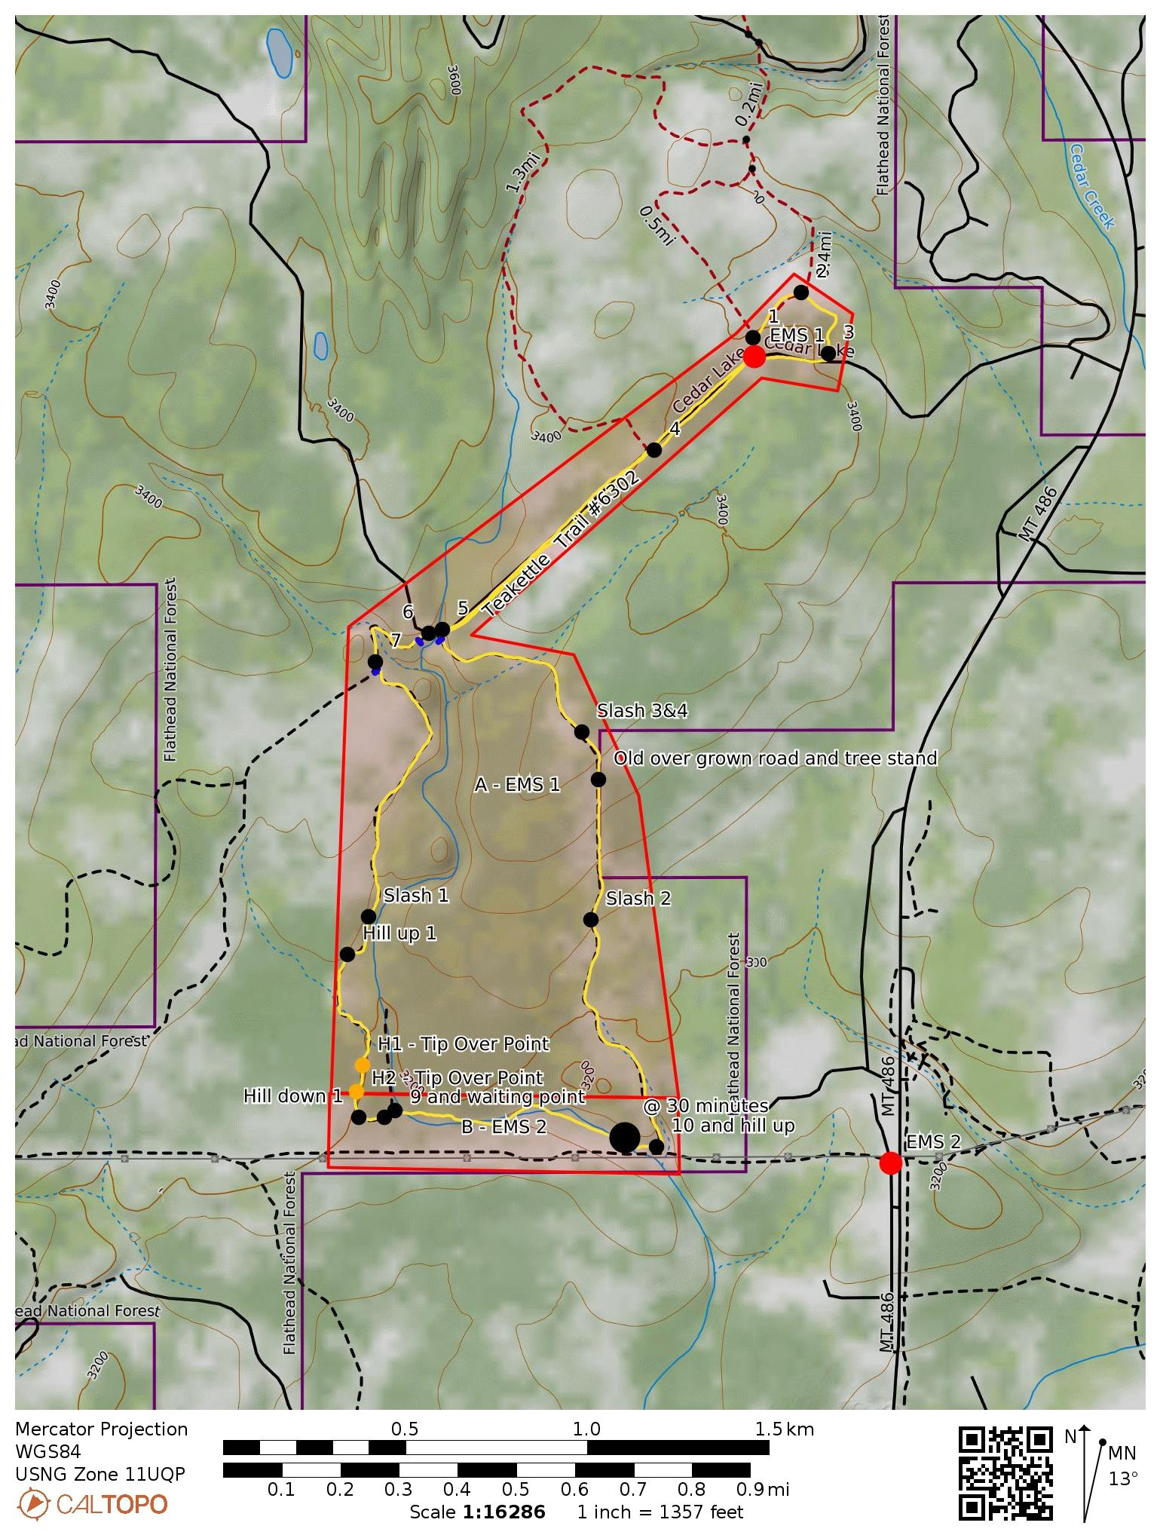
Bearfoot trail #6500 = .41 miles, 30’ elevation change. Loop Trail.
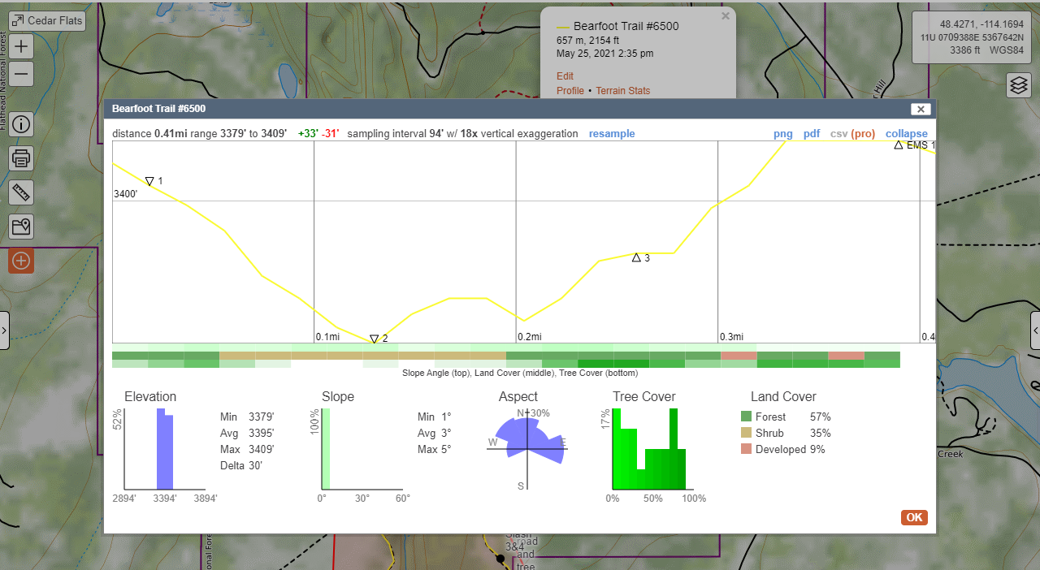

Teakettle trail #6302 = 4.23 miles, 261’ elevation change. Loop Trail.
